From the Internet.

Shared Memory
Shared memory is one of the three inter-process communication (IPC) mechanisms available under Linux and other Unix-like systems. In the case of shared memory, a shared memory segment is created by the kernel and mapped to the data segment of the address space of a requesting process. A process can use the shared memory just like any other global variable in its address space.
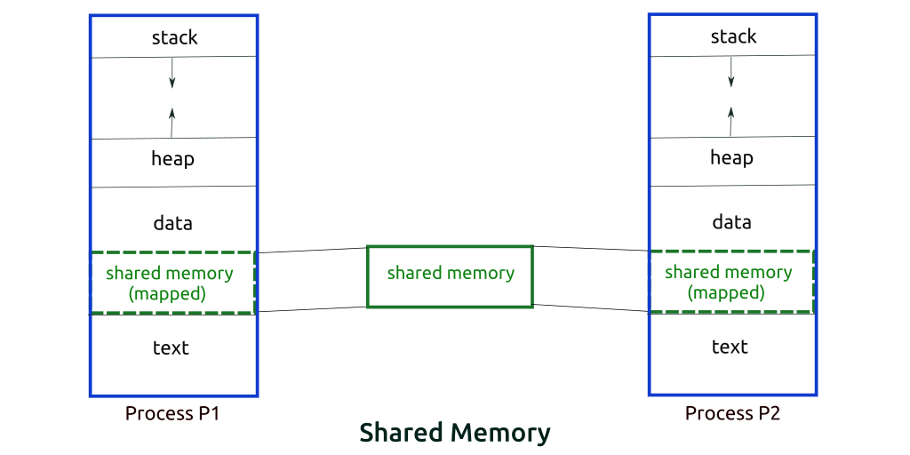
In the interprocess communication mechanisms like the pipes and message queues, the work involved in sending data from one process to another is like this. Process P1 makes a system call to send data to Process P2. The message is copied from the address space of the first process to the kernel space during the system call for sending the message. Then, the second process makes a system call to receive the message. The message is copied from the kernel space to the address space of the second process. The shared memory mechanism does away with this copying overhead. The first process simply writes data into the shared memory segment. As soon as it is written, the data becomes available to the second process. Shared memory is the fastest mechanism for interprocess communication.

System V and POSIX Shared Memory
Shared memory comes in two flavors, the traditional System V shared memory and the newer POSIX shared memory.

System V IPC key
To use System V IPC mechanism, we need a System V IPC key. The ftok function, which does the job, is
#include <sys/types.h>
#include <sys/ipc.h>

key_t ftok (const char *pathname, int proj_id);
The pathname is an existing file in the filesystem. The last eight bits of proj_id are used; these must not be zero. A System V IPC key is returned.

System V Shared Memory Calls

shmget
#include <sys/ipc.h>
#include <sys/shm.h>

int shmget (key_t key, size_t size, int shmflg);
As the name suggests, shmget gets you a shared memory segment associated with the given key. The key is obtained earlier using the ftok function. If there is no existing shared memory segment corresponding to the given key and IPC_CREAT flag is specified in shmflg, a new shared memory segment is created. Also, the key value could be IPC_PRIVATE, in which case a new shared memory segment is created. size specifies the size of the shared memory segment to be created; it is rounded up to a multiple of PAGE_SIZE. If shmflg has IPC_CREAT | IPC_EXCL specified and a shared memory segment for the given key exists, shmget fails and returns -1, with errno set to EEXIST. The last nine bits of shmflg specify the permissions granted to the owner, group and others. The execute permissions are not used. If shmget succeeds, a shared memory identifier is returned. On error, -1 is returned and errno is set to the relevant error.

shmat
#include <sys/types.h>
#include <sys/shm.h>

void *shmat (int shmid, const void *shmaddr, int shmflg);
With shmat, the calling process can attach the shared memory segment identified by shmid. The process can specify the address at which the shared memory segment should be attached with shmaddr. However, in most cases, we do not care at what address system attaches the shared memory segment and shmaddr can conveniently be specified as NULL. shmflg specifies the flags for attaching the shared memory segment. If shmaddr is not null and SHM_RND is specified in shmflg, the shared memory segment is attached at address rounded down to the nearest multiple of SHMLBA, where SHMLBA stands for Segment low boundary address. The idea is to attach at an address which is a multiple of SHMLBA. On most Linux systems, SHMLBA is the same as PAGE_SIZE. Another flag is SHM_RDONLY, which means the shared memory segment should be attached with read-only access.
On success, shmat returns pointer to the attached shared memory segment. On error, (void *) -1 is returned, with errno set to the cause of the error.

shmdt
#include <sys/types.h>
#include <sys/shm.h>

int shmdt (const void *shmaddr);
shmdt detaches a shared memory segment from the address space of the calling process. shmaddr is the address at which the shared memory segment was attached, being the value returned by an earlier shmat call. On success, shmdt returns 0. On error, shmdt returns -1 and errno is set to indicate the reason of error.

shmctl
#include <sys/ipc.h>
#include <sys/shm.h>

int shmctl (int shmid, int cmd, struct shmid_ds *buf);
The shmctl call is for control operations of a System V shared memory segment identified by the shmid identifier, returned by an earlier shmget call. The data structure for shared memory segments in the kernel is,
struct shmid_ds {
struct ipc_perm shm_perm; /* Ownership and permissions */
size_t shm_segsz; /* Size of segment (bytes) */
time_t shm_atime; /* Last attach time */
time_t shm_dtime; /* Last detach time */
time_t shm_ctime; /* Last change time */
pid_t shm_cpid; /* PID of creator */
pid_t shm_lpid; /* PID of last shmat(2)/shmdt(2) */
shmatt_t shm_nattch; /* No. of current attaches */
...
};
Where. the struct ipc_perm is,
struct ipc_perm {
key_t __key; /* Key supplied to shmget(2) */
uid_t uid; /* Effective UID of owner */
gid_t gid; /* Effective GID of owner */
uid_t cuid; /* Effective UID of creator */
gid_t cgid; /* Effective GID of creator */
unsigned short mode; /* Permissions + SHM_DEST and
SHM_LOCKED flags */
unsigned short __seq; /* Sequence number */
};
The cmd parameter in shmctl specifies the command. The important commands are IPC_STAT, IPC_SET, and IPC_RMID. The IPC_STAT command copies the data in the kernel data structure shmid_ds for the shared memory into the location pointed by the parameter buf. With the IPC_SET command, we can set some of the fields in the shmid_ds structure in the kernel for the shared memory segment. The fields that can be modified are shm_perm.uid, shm_perm.gid and the least significant 9 bits of shm_perm.mode. The command, IPC_RMID, marks a shared memory segment for removal from the system. The shared memory segment is actually removed after the last process detaches it from its address space.

An example: Reader and Writer:
/* Filename: shm_write.c */
#include<stdio.h>
#include<sys/ipc.h>
#include<sys/shm.h>
#include<sys/types.h>
#include<string.h>
#include<errno.h>
#include<stdlib.h>
#include<unistd.h>
#include<string.h>
#define BUF_SIZE 16
struct shmseg {
int cnt;
int complete;
char buf[BUF_SIZE];
};
int fill_buffer(char * bufptr, int size);

int main(int argc, char *argv[]) {
int shmid, numtimes;
struct shmseg *shmp;
char *bufptr;
int spaceavailable;
key_t key = ftok("abc",11);
shmid = shmget(key, sizeof(struct shmseg), 0644|IPC_CREAT);
if (shmid == -1) {
perror("Shared memory");
return 1;
}
// Attach to the segment to get a pointer to it.
shmp = shmat(shmid, NULL, 0);
if (shmp == (void *) -1) {
perror("Shared memory attach");
return 1;
}
/* Transfer blocks of data from buffer to shared memory */
bufptr = shmp->buf;
spaceavailable = BUF_SIZE;
for (numtimes = 0; numtimes < 5; numtimes++) {
shmp->cnt = fill_buffer(bufptr, spaceavailable);
shmp->complete = 0;
printf("Writing Process: Shared Memory Write: Wrote %d bytes\n", shmp->cnt);
bufptr = shmp->buf;
spaceavailable = BUF_SIZE;
sleep(3);
}
printf("Writing Process: Wrote %d times\n", numtimes);
shmp->complete = 1;

if (shmdt(shmp) == -1) {
perror("shmdt");
return 1;
}
printf("Writing Process: Complete\n");
return 0;
}

int fill_buffer(char * bufptr, int size) {
static char ch = 'A';
int filled_count;
//printf("size is %d\n", size);
memset(bufptr, ch, size - 1);
bufptr[size-1] = '\0';
if (ch > 122)
ch = 65;
if ( (ch >= 65) && (ch <= 122) ) {
if ( (ch >= 91) && (ch <= 96) ) {
ch = 65;
}
}
filled_count = strlen(bufptr);

printf("buffer count is: %d\n", filled_count);
//printf("buffer filled is:%s\n", bufptr);
ch++;
return filled_count;
}
/* Filename: shm_read.c */
#include<stdio.h>
#include<sys/ipc.h>
#include<sys/shm.h>
#include<sys/types.h>
#include<string.h>
#include<errno.h>
#include<stdlib.h>
#define BUF_SIZE 16
struct shmseg {
int cnt;
int complete;
char buf[BUF_SIZE];
};

int main(int argc, char *argv[]) {
int shmid;
struct shmseg *shmp;
key_t key = ftok("abc",11);
shmid = shmget(key, sizeof(struct shmseg), 0644|IPC_CREAT);
if (shmid == -1) {
perror("Shared memory");
return 1;
}
// Attach to the segment to get a pointer to it.
shmp = shmat(shmid, NULL, 0);
if (shmp == (void *) -1) {
perror("Shared memory attach");
return 1;
}
/* Transfer blocks of data from shared memory to stdout*/
while (shmp->complete != 1) {
printf("segment contains : \n\"%s\"\n", shmp->buf);
if (shmp->cnt == -1) {
perror("read");
return 1;
}
printf("Reading Process: Shared Memory: Read %d bytes\n", shmp->cnt);

sleep(3);
}
printf("Reading Process: Reading Done, Detaching Shared Memory\n");
if (shmdt(shmp) == -1) {
perror("shmdt");
return 1;
}
if (shmctl(shmid, IPC_RMID, 0) == -1) {
perror("shmctl");
return 1;
}
printf("Reading Process: Complete\n");
return 0;
}

Run the above code. Open two terminals, at one terminal compile writer code and on second compile reader code. Thereafter, first, run writer and then reader code. You can choose any order to understand synchronization between the codes. Modify the sleep argument and check the output of both the program.

Semaphore: There are two types of semaphores: binary and counting. Binary semaphore has only two values: lock or unlock. These semaphores can only be used for the non-shareable environment such as database modification. A counting semaphore is used in shareable environment such as reading from the database. A very simple example of the use of both the semaphores is reader-writer problem. In this problem more than one reader can read the critical section. However, during the reading process no writer will be allowed to modify the critical section. So, writer has to wait. In another scenario, if any writer is writing in the critical section than neither any reader nor any writer will be allowed to enter into critical section. Linux provides two alternatives of semaphores: System V and POSIX semaphores. Next week lab will be on POSIX semaphores, So study it

